1. 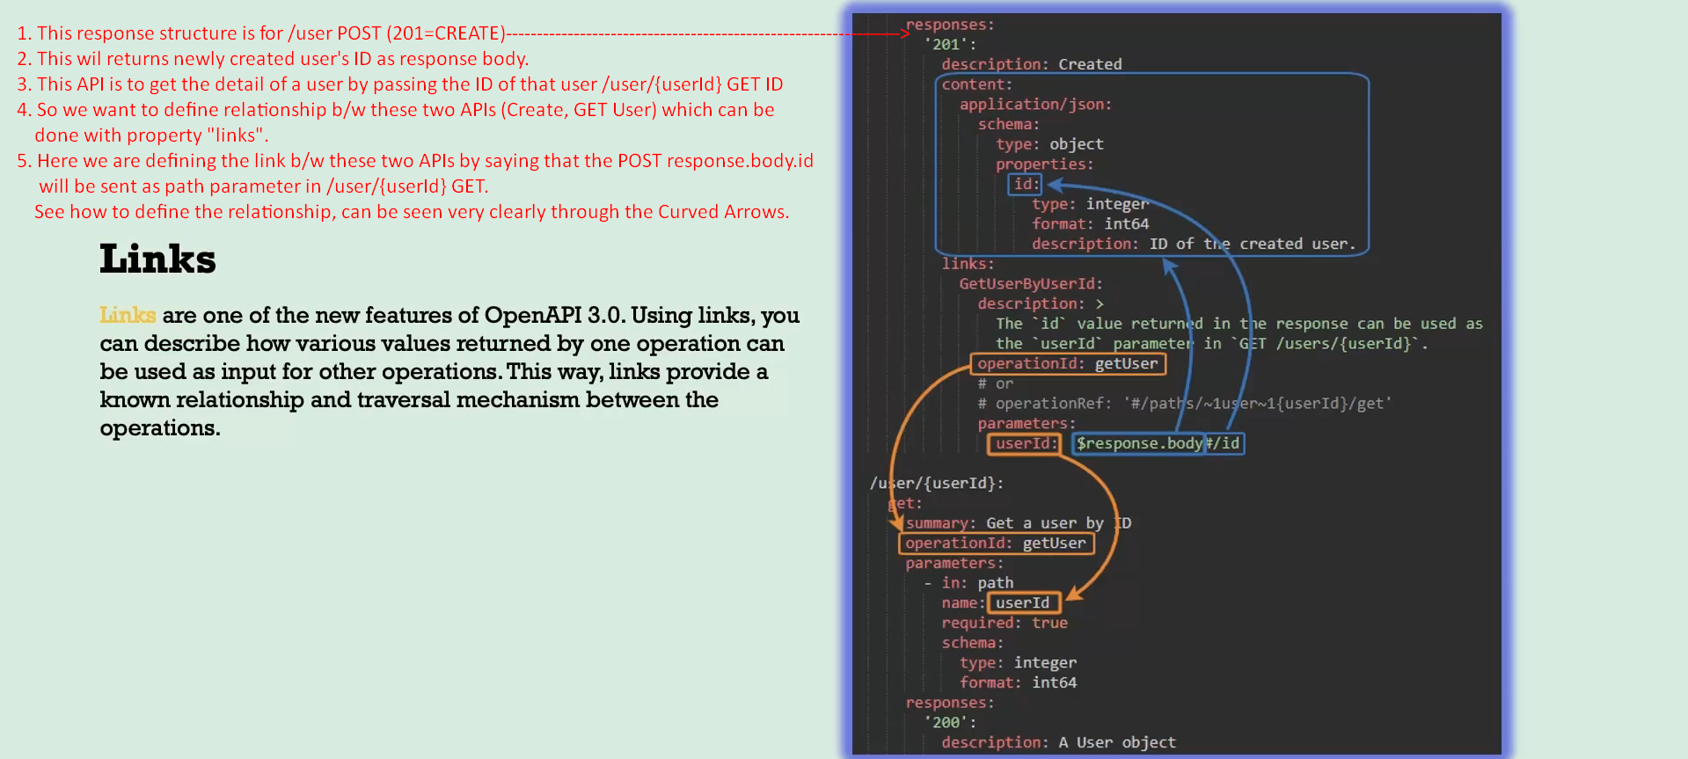
2. Let’s go to the Swagger Editor.
3. 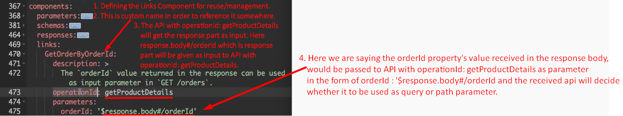
4. 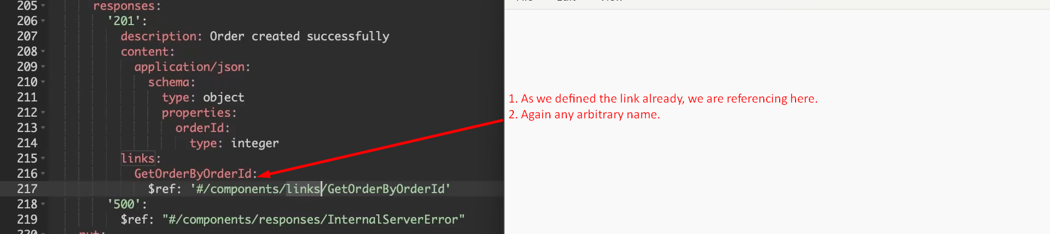
5. 